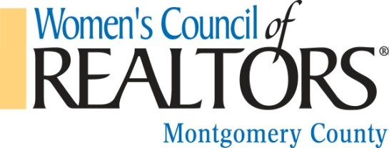
Local Strategic Partners 2017

Sonya Bersani
Cherry Creek Mortgage
267-934-2659
sbersani@ccmclending.com

Michael Boltz
Boltz Law
832-381-3070
boltz@boltzlaw.com

Catherine Fuller
S & H Flooring
832-517-1217
cfuller@shflooring.com

Shari Joyce
Pillar to Post
936-777-4708
Shari.joyce@pillartopost

Kim Kocian
Atlantic Bay Mortgage
713-775-9167
kimkocian@atlanticbay.com

Maria Saunders
Veritas Title
281-364-1500
Maria.saunders@fnfw.net

Kimberly Van Pelt
Farmers Insurance
281-796-8522
Micah Horton
Rockland Insurance
281-914-3577
micah@gorockland.com

