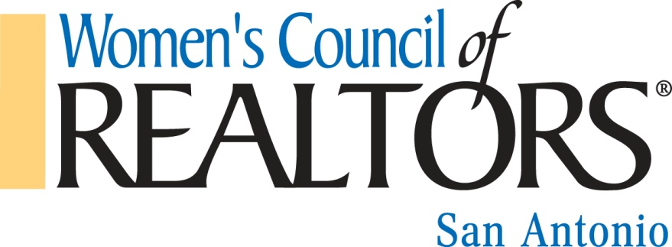

Entrepreneur of the Year Award Application Form

Deadline: November 27, 2017

Applicant should complete application and submit with photo to:
Scott Jauregi
Scott@ScottJREALTOR.com
(210) 364-9434

APPLICATION FORM

Eligibility

Must be a member of national Women’s Council of REALTORS® for minimum of one year.

Must have been a REALTOR® or REALTOR-ASSOCIATE® for a minimum of one year.

Sales Agent Application form must be signed by Association Executive Officer or Broker. Broker/Manager/Owner Application form must be signed by Association Executive Officer.

Name:

Company:

City/State/Zip:

Email Address:

Phone:

Check One

___ REALTOR®
___ REALTOR® -ASSOCIATE

Category 1 Business Accomplishments: 50%

Please answer the following questions:
- Describe a recent business initiative that yielded outstanding business results.

- Describe how you are doing business differently from 5 years ago and what benefits this had yielded.

- What recommendations would you make to someone new to the profession?

Category 2 Production: Check one and complete information 5%

___ Sales Agent - Annual Production $________
___ Broker/Owner/Manager – Units sold_____________/number of sales agents___________

Category 3 Education: Degrees or Professional education (with dates) 5%

Category 4 REALTOR® Local/State/National Leadership: (with dates) 10%

Category 5 Describe How You Have Mentored others in the Real Estate Profession: 15%

Category 6 List Political/Business Community Involvement: (with dates) 10%

Public offices held/campaigned for:

Business Community involvement:

Membership in Professional Organizations:

Category 7 Career Achievements: Describe outstanding accomplishments in your career or special recognition: 5%

Signature of REALTOR® Association EO or Broker/Owner________________________

