September 12th, 2013 4:00 - 7:00
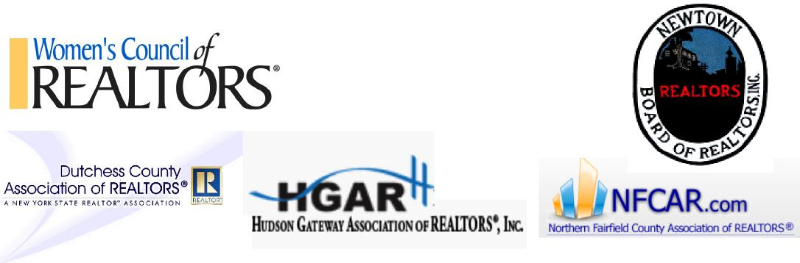
Clancy Moving Warehouse: 7 Edmund Rd, Newtown, CT
$15 includes Hor Dourves, Wine, Music, Networking, and more!
All proceeds will be donated to the Newtown Rotary - Sandy Hook School Fund.
*Bus transportation from Fishkill (Departs Dutchess Mall McDonalds at 3:00pm)
Only 55 seats available on the bus- first come first serve, RESERVE YOURS NOW!
Contact Dawne Salamone at 845.453.0925 or dawnesellshomes@optonline.net
Don’t forget cash for raffles!
with participation from:
Dutchess County NY Chapter
Empire Westchester NY Chapter Greater Hudson Valley NY Chapter Greater Danbury CT Chapter
Southern Fairfield County CT Chapter

Register at:
https://www.paypal.com/cgi-bin/webscr?cmd= s-xclick&hosted button id=NVHHERUHXHF7Q

