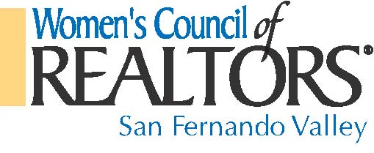
2015 STRATEGIC PARTNERSHIP AND SPONSORSHIP LEVELS APPLICATION:

Company/ Partner Names: __________________________________________
Partnership/ Sponsor Levels_________________________ Amount:________
________________________________________________________________
Event Dates:______________________________________________________
Card Holder Names: _______________________________________________
Billing Address:___________________________________________________
Card Type: __________Card Number: _________________________________
Expired Date: ____________Sec Code: _______Phone #_________________
Authorized Signature: ______________________________________________
Email Address:____________________________________________________
Please mail Check payment to:
Women’s Council of REALTORS®
P.O. Box 572494, Tarzana, Ca. 91357
or
www.partnerandsponsors2015@eventbrite.com to pay by credit card
Any Questions:
Catherine da Gama - President Email: catherinedagama1@gmail.com
Helen Kerwin-Saltzman- President-Elect Email: helensaltzman@yahoo.com
This signed document will act as a contract and receipt between the Strategic Partner and Women’s Council of REALTORS® for the calendar year of 2015
Women’s Council of REALTORS® 501 (c-6) Tax Payer ID # 90-0444663

