Metro South | April 2016 • Volume 1, Issue 4
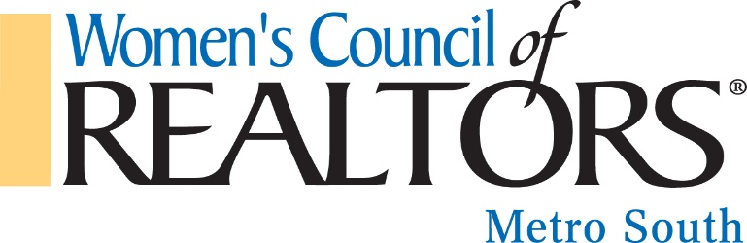
Mission:
We are a network of successful REALTORS® empowering women to exercise their potential as entrepreneurs and industry leaders.

VISION STATEMENT:
Through our influence as successful business professionals, women will effect positive change in the profession and in the broader community.

Governing Board  President  Tammy Noll  Oliver Adams Realty, LLC  President-elect  Brande Bradford  Academy Properties  VP, Membership  Amy Hudgins  Apple Realty, INC  Secretary  Standish Ponder  Crowe Realty  Treasurer  Dean Bendall  HomeBridge Mortgage  Membership Chair  Les Lane  Academy Properties  Finance & Budget Chair  Carole Hodge  Wells Fargo  Marketing Chair  Angela Ham  Keller William Realty Atlanta Classic  Education Chair  Michelle Griffin  Preferred Realty Partners, LLC  Ways & Means Chair  Karen Devonshire  Sparks/King/Watts Law Firm  Hospitality Committee  Wanda Stoy  Light House Inspections  Awards & Recognition  Gloria Easler  Southside Realtors | April Business Resource Meeting  Featuring: Kit Cummimgs  Location: Pinehurst Event Center  108 South Lee Street  Stockbridge, GA 30281  Cost: $10 per member; $15 non-member  RSVP Very Important email nolltammyj@gmail by 3/9/16.  We are honored to have Kit Cummings with us this month. He will share about the “The Power with In Us”. Kit brings with him a wealth of knowledge about Real Estate and how to stay Pump Up in our industry.  We had a great time at the Habitat Build and gearing up for another Women’s build in the fall. Stay tuned.  MAY 5TH CINCO DE MAYO “TASTE FOR CHARITY”  TIME: 6-10PM  LOCATION: PILGREENS  1720 Lake Dow Rd, McDonough, GA 30253  ORDER YOUR TICKETS NOW SEE THE ATTACHED FLYER.  Thank You to Our April Sponsor!  Chris Ragan 770-357-0071  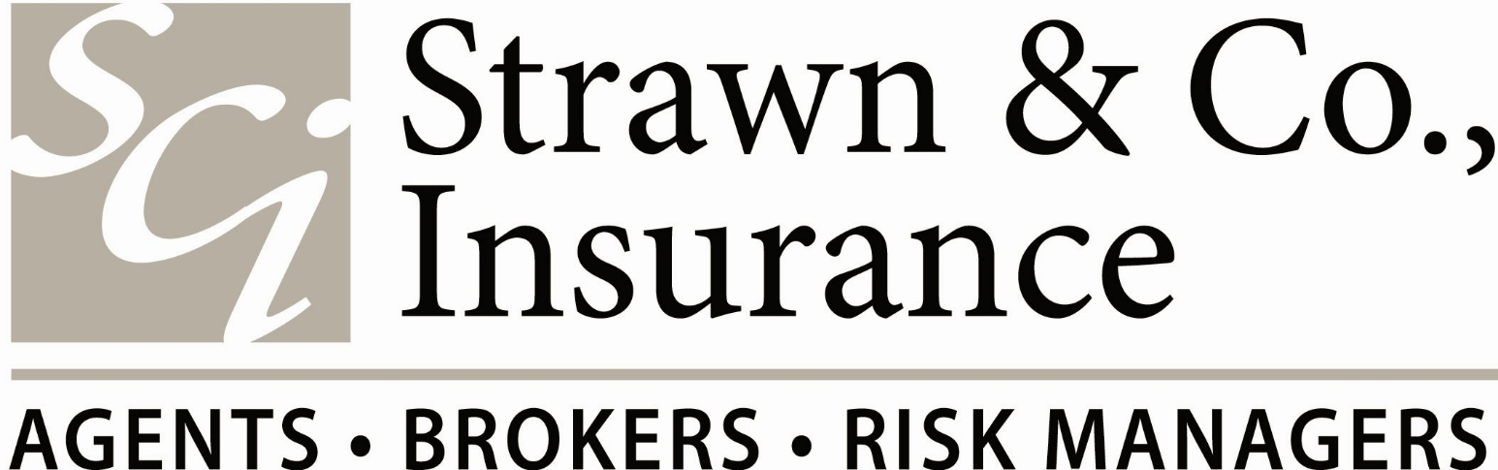  NEW MEMBER ORIENTATION  If you joined Women’s Council and have not attended New Member Orientation.  Then this is for “YOU”  Tuesday April 26th 6:30-8:30pm  Logan Roadhouse Garage.  20 Mill Road McDonough GA 30253  Please RSVP to Amy Hudgins  678-414-2978 amyhudgins@bellsouth.net Les Lane 770-756-7355 leslanesells4u@gmail.com

METRO SOUTH ASSOCIATION OF REALTORS®
“OPEN HOUSE”

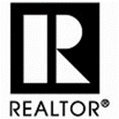

Fair Housing/ Special Awards General Membership & Association Luncheon

An afternoon filled with Fair Housing information, Special Awards Recognition.

View the newly renovated Metro South Association
Building.

Play BINGO! With…You guessed it. Stephan Walker from the Fayette Board. You have not played Bingo until you played with Stephan. Great Fun!!!

Member Benefit Event, Registrations required via the Association website: www.msar.org

This event is courtesy of the Metro South Association of REALTORS®!
1671 Adamson Parkway, Morrow, GA 30260
Office: 770.477.7579 Website: www.msar.org
Senior Vice President: Christy Slaton
Email: msar3020@gmail.com

LARGE GREEN EGG
RAFFLE.

WHY???
YOUR LEADERSHIP TEAM IS GOING TO MID YEAR IN MAY

Dear Members,

One of my goals this year is to develop a strong leadership team and build future leaders for Women’s Council of REALTORS Metro South. In doing so I have challenged each member of our Board to participate in GAR & NAR Conventions where they can gain lots of training and education through participating and networking with other Women’s Council Member’s from across the State and Nation. They will be able to attend Governing Board Meetings on the State & National Level. Amy Hudgins, Les Lane & Carole Hodge had the opportunity to observe my first State Board Meeting in February and if you ask them they will tell you it was an “eye opening moment”. They were so excited & proud to be a part of Women’s Council and to hear our Chapter called out for being #1 so far in New Members & #1 so far in Member Retention.

Let’s help them get to Mid -Year in May…

Tammy Noll
2016 President.

Raffle tickets are $5.00 & each member of your leadership team has 150 tickets to sell before May 1st.

We will drawl the Winner in May just in time for all the summer cook outs. And the Best News is Smith Douglas Homes has donated the Green Egg to Women’s Council. Thank you Smith Douglas Homes and we are proud to have you as a sponsor and member of Women’s Council of REALTORS.

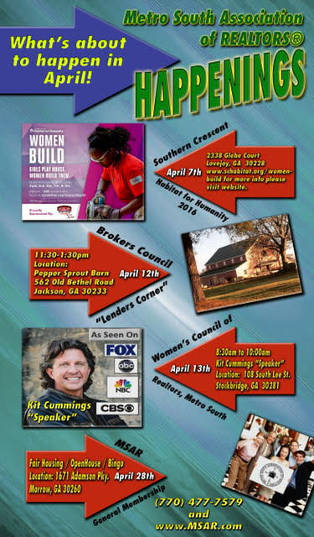

FUTURE BUSINESS RESOURCE MEETINGS

May 19th 8:30-10:00
Honoring Past Presidents and History of Women's Council of Realtors.
“Past Presidents Speak Out".

June 9th 8:30-10:00 am
Speaker: Oliver Adams
“Power 2 Live”

July 14th 8:30-10:00am
Speaker: Shane Persuad President of the "Fuller Project"
Will speak about community projects in Henry and Clayton County.

Aug 11th 8:30-10:00am
Speaker: Brande Bradford will address the
Membership on her trip to the 2016 Leadership Academy in Chicago.

Sept 15th 8:30-10:00am
Speaker: Jere Metcalfe
Sotheby's Fine Homes/ Luxury Market

Oct 13th 8:30-10:00am
Speaker: TBD

November 10th 8:30-10:00am.
Speaker: Affiliate Appreciation

December No Meeting
We will do a combined Luncheon with MSAR for
Our Installation of New Officers.

