2017
Realtor Member of the Year
Kathleen Phillips
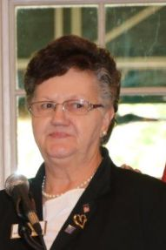
Kathleen Phillips is the award recipient of the 2017 WCR Dayton Network Realtor Member of the Year. She has been a Realtor since January of 1990 and a member of WCR since 1997.
She served as President-Elect in 1999; President in 2000; President-Elect in 2004 and President in 2005; Vice President of Membership 2013-2014.
Kathleen served as the Annual Report Chair 2004-2017; State Strategic Planning Committee 2004; Finance and Budget Chair 2013-2017; Bylaws and Standing Rules Chair 2005-2017; Holiday Gala committee 1997-2017; Participated in the Management of the Local and National Website 2013-2017.
In her real estate business, she has received many sales achievement awards from Better Homes and Gardens Real Estate Big Hill. Kathleen takes pride in helping people in and around the community achieve the American dream.

Kathleen Phillips
Better Homes and Gardens Real Estate
5580 Far Hills Ave
Dayton, OH 45429-2228
Business Phone: 937-718-7407
Email: kathleen@bighill.com
Website: http://www.bighill.com/kphillips

